|  |  |  |  |  |
| --- | --- | --- | --- | --- |
| Dhairya Vyas |  | |  | | --- | | **Dot Net Technology – 2160711**  **Lab Manual**  Semester 6th  Academic Year 2019-20 Even  12th December 2019 – 14th April 2020 | |  | |



Gujarat Technological University

VVP Engineering College, Rajkot

Table of Contents

1. Creating a hello World program using C# 3
2. Generating various patterns in C# 4
3. Getting input from user in C# 8
4. INTFIX TO POSTFIX 9
5. CONVERSIONs 11
6. digits to words 13
7. Currency Conversion 16
8. Temperature conversion 17
9. Change Font size 18
10. Check Empty String 20
11. Change colour of Label 25
12. Textbox configuration 29
13. Session State in SQL Server 31

**Practical 1**

# Creating a hello World program using C#

***Program.cs:***

using System;

using System.Collections.Generic;

using System.Linq;

using System.Text;

using System.Threading.Tasks;

namespace Practical1

{

class Program

{

static void Main(string[] args)

{

Console.WriteLine("Hello World !!");

Console.Read();

}

}

}

**Practical 2**

# Generating various patterns in C#

***Program.cs:***

using System;

using System.Collections.Generic;

using System.Linq;

using System.Text;

using System.Threading.Tasks;

namespace Practical2 // This practical prints different patterns

{

class Program

{

/* * This pattern prints

* * * * * *

* * * * * *

* * * * * *

* * * * * *

* * * * * *

*/

public static void Pattern1()

{

for(int i = 0; i < 5; i++)

{

for (int j = 0; j < 5; j++)

Console.Write(" *");

Console.WriteLine();

}

}

/* * This pattern prints

* *

* * *

* * * *

* * * * *

* * * * * *

*/

public static void Pattern2()

{

for(int i = 0; i < 5; i++)

{

for (int j = 0; j <= i; j++)

Console.Write(" *");

Console.WriteLine();

}

}

/* * This pattern prints

* * * * * *

* * * * *

* * * *

* * *

* *

*/

public static void Pattern3()

{

for (int i = 0; i < 5; i++)

{

for (int k = 4; k > i; k--)

Console.Write(" ");

for (int j = 0; j <= i; j++)

Console.Write(" *");

Console.WriteLine();

}

}

/* * This pattern prints

* *

* * *

* * * *

* * * * *

* * * * * *

*/

public static void Pattern4()

{

for (int i = 0; i < 5; i++)

{

for (int k = 4; k > i; k--)

Console.Write(" ");

for (int j = 0; j <= i; j++)

Console.Write(" *");

Console.WriteLine();

}

}

/* * This pattern prints

* * * * * *

* * * * *

* * * *

* * *

* *

*/

public static void Pattern5()

{

for (int i = 0; i < 5; i++)

{

for (int k = 0; k < i; k++)

Console.Write(" ");

for (int j = 4-i; j >= 0; j--)

Console.Write(" *");

Console.WriteLine();

}

}

/* * This pattern prints

* *

* * *

* * * *

* * * * *

* * * * * *

* * * * *

* * * *

* * *

* *

*/

public static void Pattern6()

{

for(int i = 0; i < 9; i++)

{

if (i < 5)

{

for (int k = 4; k > i; k--)

Console.Write(" ");

for (int j = 0; j <= i; j++)

Console.Write(" *");

Console.WriteLine();

}

else

{

for (int k = 0; k < i-4; k++)

Console.Write(" ");

for (int j = 8 - i; j >= 0; j--)

Console.Write(" *");

Console.WriteLine();

}

}

}

static void Main(string[] args)

{

Console.WriteLine("\tPattern 1\n");

Pattern1();

Console.WriteLine("\tPattern 2\n");

Pattern2();

Console.WriteLine("\tPattern 3\n");

Pattern3();

Console.WriteLine("\tPattern 4\n");

Pattern4();

Console.WriteLine("\tPattern 5\n");

Pattern5();

Console.WriteLine("\tPattern 6\n");

Pattern6();

Console.Read();

}

}

}

**Output:**

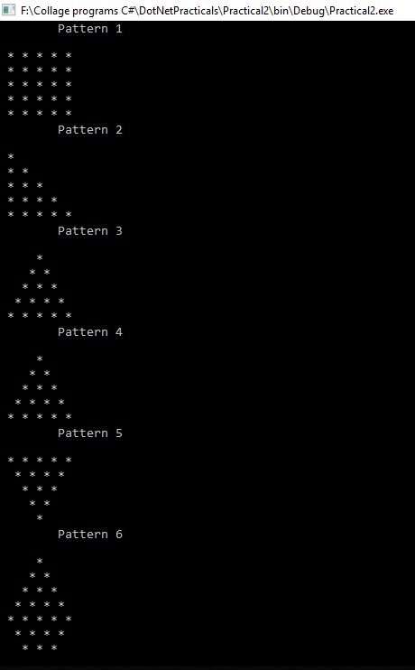

**Practical 3**

# Getting input from user in C#

***Program.cs:***

using System;

using System.Collections.Generic;

using System.Linq;

using System.Text;

using System.Threading.Tasks;

using System.Text.RegularExpressions;

// Simple Practical to take name and country as a input from user and display it after validating it

namespace Practical3

{

class Program

{

static void Main(string[] args)

{

string name, country;

Regex regex = new Regex(@"^[a-z]+$", RegexOptions.IgnoreCase);

// In this ary ^ stands for "must start with", + stands for 1 or more chars, $ stands for must end with

Console.WriteLine("!!! Warning :- Entered Name and Countery must be alphabets only else you will have to enter again.\n");

do {

Console.Write("Enter Your Name : ");

name = Console.ReadLine();

} while (regex.IsMatch(name) == false);

do

{

Console.Write("Enter Your Country name : ");

country = Console.ReadLine();

} while (regex.IsMatch(country) == false);

Console.WriteLine("Hey " + name + ",From " + country + ".");

Console.Read();

}

}

}

**OUTPUT:-**

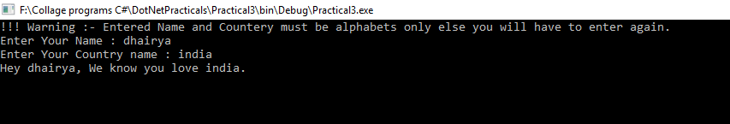

**Practical 4**

# INTFIX TO POSTFIX

***Program.cs:***

using System;

using System.Collections.Generic;

using System.Linq;

using System.Text;

using System.Threading.Tasks;

namespace Practical4

{

class Program

{

bool IsAlNum(char c)

{

// Console.WriteLine(c);

if (c >= 'a' && c <= 'z')

return true;

if (c >= 'A' && c <= 'Z')

return true;

return false;

}

int Priority(char c)

{

if (c == '^' || c == '$')

return 3;

if (c == '%' || c == '*' || c == '/')

return 2;

if (c == '+' || c == '-')

return 1;

return 0;

}

string InfixToPostfix(string infix)

{

Stack<char> s = new Stack<char>();

string postfix = "";

for (int i = 0; i < infix.Length; i++)

{

char ch = infix[i];

if(!IsAlNum(ch))

{

if (s.Count == 0)

{

s.Push(ch);

continue;

}

while(s.Count !=0 && Priority(s.Peek()) >= Priority(ch))

postfix += s.Pop();

s.Push(ch);

}

else

postfix += ch;

}

while (s.Count != 0)

postfix += s.Pop();

return postfix;

}

static void Main(string[] args)

{

string infix;

Console.Write("Enter Infix String : ");

infix = Console.ReadLine();

Program p = new Program();

string postfix = p.InfixToPostfix(infix);

Console.Write("Postifix is : " + postfix);

Console.Read();

}

}

}

***Output:***

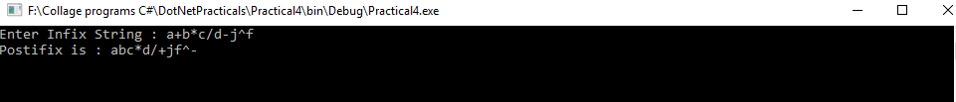

**Practical 5_6**

# CONVERSIONs

***Program.cs:***

using System;

using System.Collections.Generic;

using System.Linq;

using System.Text;

using System.Threading.Tasks;

namespace Practical5_6

{

class Program

{

public static string BinaryToDecimal(string Binary)

{

int Decimal = 0, temp, i = 0;

int binaryValue = int.Parse(Binary);

while (binaryValue > 0)

{

temp = (binaryValue % 10);

Decimal = Decimal + (temp * (int)Math.Pow(2, i));

i++;

binaryValue = binaryValue / 10;

}

string Result = $"Binary: {Binary} is converted to Decimal: {Decimal}";

return Result;

}

public static string DecimalToBinary(int decimalValue)

{

string Result = $"Decimal: {decimalValue} is converted to Binary: ";

int value = decimalValue; int i;

int[] binaryString = new int[10];

for (i = 0; value > 0; i++)

{

binaryString[i] = (value % 2);

value = value / 2;

}

i--;

for (; i >= 0; i--)

{

Result += binaryString[i].ToString();

}

return Result;

}

public static string DecimalToOctal(int decimalValue)

{

string Result = $"Decimal: {decimalValue} is converted to Octal: ";

int value = decimalValue; int i;

int[] octalString = new int[10];

for (i = 0; value > 0; i++)

{

octalString[i] = (value % 8);

value = value / 8;

}

i--;

for (; i >= 0; i--)

{

Result += octalString[i].ToString();

}

return Result;

}

public static string DecimalToHexadecimal(int decimalValue)

{

string Result = $"Decimal: {decimalValue} is converted to Hexadecimal: ";

int value = decimalValue; int i;

int[] hexadecimalString = new int[10];

for (i = 0; value > 0; i++)

{

hexadecimalString[i] = (value % 16);

value /= 16;

}

i--;

for (; i >= 0; i--)

{

switch (hexadecimalString[i])

{

case 10: Result += "A"; break;

case 11: Result += "B"; break;

case 12: Result += "C"; break;

case 13: Result += "D"; break;

case 14: Result += "E"; break;

case 15: Result += "F"; break;

default: Result += hexadecimalString[i].ToString(); break;

}

}

return Result;

}

static void Main(string[] args)

{

Console.WriteLine(BinaryToDecimal("0101"));

Console.WriteLine(DecimalToBinary(31));

Console.WriteLine(DecimalToOctal(32));

Console.WriteLine(DecimalToHexadecimal(16));

Console.ReadLine();

}

}

}

***Output:***

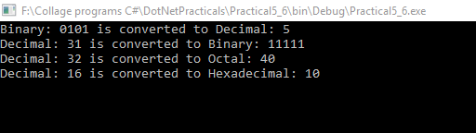

**Practical 7**

# digits to words

***Program.cs:***

using System;

using System.Collections.Generic;

using System.Linq;

using System.Text;

using System.Threading.Tasks;

namespace Practical7

{

class Program

{

static string numberToWords(int number)

{

string words = "";

switch (number)

{

case 0: words = "zero"; break;

case 1: words = "one"; break;

case 2: words = "two"; break;

case 3: words = "three"; break;

case 4: words = "four"; break;

case 5: words = "five"; break;

case 6: words = "six"; break;

case 7: words = "seven"; break;

case 8: words = "eight"; break;

case 9: words = "nine"; break;

case 10: words = "ten"; break;

case 11: words = "eleven"; break;

case 12: words = "twelve"; break;

case 13: words = "thirteen"; break;

case 14: words = "fourteen"; break;

case 15: words = "fifteen"; break;

case 16: words = "sixteen"; break;

case 17: words = "seventeen"; break;

case 18: words = "eighteen"; break;

case 19: words = "nineteen"; break;

case 20: words = "twenty"; break;

case 30: words = "thirty"; break;

case 40: words = "forty"; break;

case 50: words = "fifty"; break;

case 60: words = "sixty"; break;

case 70: words = "seventy"; break;

case 80: words = "eighty"; break;

case 90: words = "ninety"; break;

case 100: words = "hundred"; break; //number > 100

case 1000: words = "thousand"; break; //number > 1000

case 1000000: words = "million"; break; //number > 1000

}

return words;

}

static int numberOfDigits(int number)

{

return (int)(Math.Log10(number) + 1);

}

static void Main(string[] args)

{

int number = 5678, i = numberOfDigits(number);

Console.Write(number + " in words :: ");

while (number > 0)

{

int tempNumber;

if (number % Math.Pow(10, i) > Math.Pow(10, i - 1))

{

tempNumber = number % (int)Math.Pow(10, i);

if (tempNumber > 100)

{

Console.Write(numberToWords(tempNumber / (int)Math.Pow(10, i - 1)) + " ");

Console.Write(numberToWords((int)Math.Pow(10, i - 1)) + " ");

}

else

{

if (tempNumber > 19)

Console.Write(numberToWords(tempNumber / 10 * 10) + " ");

else

{

Console.Write(numberToWords(tempNumber) + " ");

}

}

}

number = number % (int)Math.Pow(10, i - 1);

i--;

}

Console.ReadLine();

}

}

}

***Output:***



**Practical 8**

# Currency Conversion

***Program.cs:***

using System;

using System.Collections.Generic;

using System.Linq;

using System.Text;

using System.Globalization;

using System.Threading.Tasks;

namespace Practical8

{

class Program

{

static void Main(string[] args)

{

Console.Write("Enter amount in Rupee :: ");

decimal Rupee, Dollar, Franc, Euro;

Rupee = decimal.Parse(Console.ReadLine());

Dollar = Rupee * 0.0135107M;

Franc = Rupee * 0.0126123M;

Euro = Rupee * 0.0119623M;

Console.OutputEncoding = System.Text.Encoding.UTF8;

Console.WriteLine($"Dollar:{Dollar.ToString("C", new CultureInfo("en-US"))}");

Console.WriteLine($"Frank: {Franc.ToString("C", new CultureInfo("de-CH"))}");

Console.WriteLine($"Euro: {Euro.ToString("C", new CultureInfo("es-ES"))}");

Console.ReadLine();

}

}

}

***Output:***

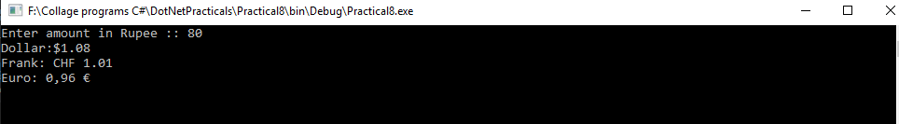

**Practical 9**

# Temperature conversion

***Program.cs:***

using System;

using System.Collections.Generic;

using System.Linq;

using System.Text;

using System.Threading.Tasks;

namespace Practical9

{

class Program

{

static void Main(string[] args)

{

Console.WriteLine("Temperature Converter\n");

Console.WriteLine("1. To convert Celsius to Fahrenheit");

Console.WriteLine("2. To convert Fahrenheit to Celsius\n");

Console.Write("Enter your choice :: ");

int choice = int.Parse(Console.ReadLine());

switch (choice)

{

case 1:

Console.Write("Enter a value in Celsius :: ");

float Celsius = float.Parse(Console.ReadLine());

float Fahrenheit = Celsius * (9.0f / 5.0f) + 32;

Console.WriteLine($"Fahrenheit :: {Fahrenheit}");

break;

case 2:

Console.Write("Enter a value in Fahrenheit :: ");

Fahrenheit = float.Parse(Console.ReadLine());

Celsius = (Fahrenheit - 32) * (5.0f / 9.0f);

Console.WriteLine($"Celsius :: {Celsius}");

break;

default:

Console.WriteLine("Invalid Option Selected.");

break;

}

Console.ReadLine();

}

}

}

***Output:***

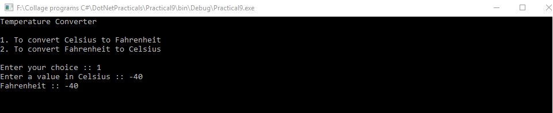

**Practical 10**

# Change Font size

***Program.cs:***

using System;

using System.Collections.Generic;

using System.Linq;

using System.Threading.Tasks;

using System.Windows.Forms;

namespace Practical10

{

static class Program

{

/// <summary>

/// The main entry point for the application.

/// </summary>

[STAThread]

static void Main()

{

Application.EnableVisualStyles();

Application.SetCompatibleTextRenderingDefault(false);

Application.Run(new Form1());

}

}

}

***Form.cs:***

using System;

using System.Collections.Generic;

using System.ComponentModel;

using System.Data;

using System.Drawing;

using System.Linq;

using System.Text;

using System.Threading.Tasks;

using System.Windows.Forms;

namespace Practical10

{

public partial class Form1 : Form

{

public Form1()

{

InitializeComponent();

}

private void Form1_Load(object sender, EventArgs e)

{

}

private void buttonIncrease_Click(object sender, EventArgs e)

{

labelText.Font = new Font(labelText.Font.Name, labelText.Font.Size + 3);

}

private void label1_Click(object sender, EventArgs e)

{

}

private void buttonDecrease_Click(object sender, EventArgs e)

{

if (labelText.Font.Size - 3 <= 0)

{

MessageBox.Show("Bas pan have ketlu hoyyy !!!!");

}

else

labelText.Font = new Font(labelText.Font.Name, labelText.Font.Size - 3);

}

}

}

***Output:***

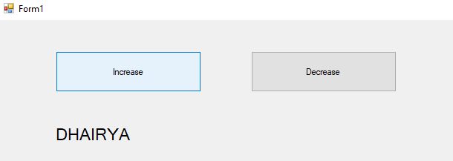

**Practical 11**

# Check Empty String

***WebForm1.aspx:***

using System;

using System.Collections.Generic;

using System.Linq;

using System.Web;

using System.Web.UI;

using System.Web.UI.WebControls;

namespace Practical11

{

public partial class WebForm1 : System.Web.UI.Page

{

protected void Page_Load(object sender, EventArgs e)

{

if (Request.QueryString.HasKeys())

{

lblUsername.Text = Request.QueryString["username"];

}

else

{

lblUsername.Text = "Empty QueryString";

}

}

}

}

***WebForm1.aspx.cs:***

using System;

using System.Collections.Generic;

using System.Linq;

using System.Web;

using System.Web.UI;

using System.Web.UI.WebControls;

namespace Practical11

{

public partial class WebForm1 : System.Web.UI.Page

{

protected void Page_Load(object sender, EventArgs e)

{

if (Request.QueryString.HasKeys())

{

lblUsername.Text = Request.QueryString["username"];

}

else

{

lblUsername.Text = "Empty QueryString";

}

}

}

}

***WebForm1.aspx.designer.cs:***

//------------------------------------------------------------------------------

// <auto-generated>

// This code was generated by a tool.

//

// Changes to this file may cause incorrect behavior and will be lost if

// the code is regenerated.

// </auto-generated>

//------------------------------------------------------------------------------

namespace Practical11

{

public partial class WebForm1

{

/// <summary>

/// form1 control.

/// </summary>

/// <remarks>

/// Auto-generated field.

/// To modify move field declaration from designer file to code-behind file.

/// </remarks>

protected global::System.Web.UI.HtmlControls.HtmlForm form1;

/// <summary>

/// lblUsername control.

/// </summary>

/// <remarks>

/// Auto-generated field.

/// To modify move field declaration from designer file to code-behind file.

/// </remarks>

protected global::System.Web.UI.WebControls.Label lblUsername;

}

}

***WebForm2.aspx:***

<%@ Page Language="C#" AutoEventWireup="true" CodeBehind="WebForm2.aspx.cs" Inherits="CheckEmptyString.WebForm2" %>

<!DOCTYPE html>

<html xmlns="http://www.w3.org/1999/xhtml">

<head runat="server">

<title></title>

</head>

<body>

<form id="form1" runat="server">

<div>

<table style="width:100%;">

<tr>

<td>&nbsp;</td>

<td>&nbsp;</td>

<td>&nbsp;</td>

</tr>

<tr>

<td>

<asp:Literal ID="Literal1" runat="server" Text="Username"></asp:Literal>

</td>

<td>

<asp:TextBox ID="txtUsername" runat="server"></asp:TextBox>

</td>

<td>&nbsp;</td>

</tr>

<tr>

<td>

<asp:Literal ID="Literal2" runat="server" Text="Password"></asp:Literal>

</td>

<td>

<asp:TextBox ID="txtPassword" runat="server"></asp:TextBox>

</td>

<td>&nbsp;</td>

</tr>

<tr>

<td>

<asp:Button ID="btnLogin" runat="server" OnClick="btnLogin_Click" Text="Login" />

</td>

<td>&nbsp;</td>

<td>&nbsp;</td>

</tr>

</table>

</div>

</form>

</body>

</html>

***WebForm2.aspx.cs:***

using System;

using System.Collections.Generic;

using System.Linq;

using System.Web;

using System.Web.UI;

using System.Web.UI.WebControls;

namespace Practical11

{

public partial class WebForm2 : System.Web.UI.Page

{

protected void Page_Load(object sender, EventArgs e)

{

}

protected void btnLogin_Click(object sender, EventArgs e)

{

string queryString = “”;

Response.Redirect("WebForm1.aspx?" + queryString);

}

}

}

***WebForm2.aspx.designer.cs:***

//------------------------------------------------------------------------------

// <auto-generated>

// This code was generated by a tool.

//

// Changes to this file may cause incorrect behavior and will be lost if

// the code is regenerated.

// </auto-generated>

//------------------------------------------------------------------------------

namespace Practical11

{

public partial class WebForm2

{

/// <summary>

/// form1 control.

/// </summary>

/// <remarks>

/// Auto-generated field.

/// To modify move field declaration from designer file to code-behind file.

/// </remarks>

protected global::System.Web.UI.HtmlControls.HtmlForm form1;

/// <summary>

/// Literal1 control.

/// </summary>

/// <remarks>

/// Auto-generated field.

/// To modify move field declaration from designer file to code-behind file.

/// </remarks>

protected global::System.Web.UI.WebControls.Literal Literal1;

/// <summary>

/// txtUsername control.

/// </summary>

/// <remarks>

/// Auto-generated field.

/// To modify move field declaration from designer file to code-behind file.

/// </remarks>

protected global::System.Web.UI.WebControls.TextBox txtUsername;

/// <summary>

/// Literal2 control.

/// </summary>

/// <remarks>

/// Auto-generated field.

/// To modify move field declaration from designer file to code-behind file.

/// </remarks>

protected global::System.Web.UI.WebControls.Literal Literal2;

/// <summary>

/// txtPassword control.

/// </summary>

/// <remarks>

/// Auto-generated field.

/// To modify move field declaration from designer file to code-behind file.

/// </remarks>

protected global::System.Web.UI.WebControls.TextBox txtPassword;

/// <summary>

/// btnLogin control.

/// </summary>

/// <remarks>

/// Auto-generated field.

/// To modify move field declaration from designer file to code-behind file.

/// </remarks>

protected global::System.Web.UI.WebControls.Button btnLogin;

}

}

***Output:***

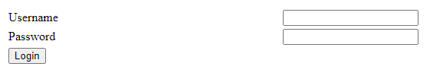



**Practical 12**

# Change colour of Label

***WebForm1.aspx:***

<%@ Page Language="C#" AutoEventWireup="true" CodeBehind="WebForm1.aspx.cs" Inherits="ChangeColourLabel.WebForm1" %>

<!DOCTYPE html>

<html xmlns="http://www.w3.org/1999/xhtml">

<head runat="server">

<title></title>

</head>

<body>

<form id="form1" runat="server">

<div>

Change the color of this label:

<asp:Label ID="lblChangingColor" runat="server" Font-Bold="True" Font-Size="30pt" Text="Label"></asp:Label><br/><br/>

<asp:Button ID="Button1" runat="server" OnClick="Button1_Click" Text="Change Color" />

</div>

<asp:Panel ID="Panel1" runat="server">

<asp:Button ID="Button2" runat="server" BackColor="Yellow" Height="50px" OnClick="Button2_Click" Width="50px" />

<asp:Button ID="Button3" runat="server" BackColor="Red" Height="50px" OnClick="Button3_Click" Width="50px" />

<asp:Button ID="Button4" runat="server" BackColor="#0033CC" Height="50px" OnClick="Button4_Click" Width="50px" />

&nbsp;

<asp:Button ID="btnSetColor" runat="server" OnClick="btnSetColor_Click" Text="Select" />

</asp:Panel>

</form>

</body>

</html>

***WebForm1.aspx.cs:***

using System;

using System.Collections.Generic;

using System.Drawing.Configuration;

using System.Linq;

using System.Web;

using System.Web.UI;

using System.Web.UI.WebControls;

namespace Practical12

{

public partial class WebForm1 : System.Web.UI.Page

{

static System.Drawing.Color color;

protected void Page_Load(object sender, EventArgs e)

{

if (!IsPostBack)

{

Panel1.Visible = false;

}

}

protected void Button1_Click(object sender, EventArgs e)

{

if (Panel1.Visible == true)

{

Panel1.Visible = false;

}

else

{

Panel1.Visible = true;

}

}

protected void Button2_Click(object sender, EventArgs e)

{

color = System.Drawing.Color.Yellow;

}

protected void Button3_Click(object sender, EventArgs e)

{

color = System.Drawing.Color.Red;

}

protected void Button4_Click(object sender, EventArgs e)

{

color = System.Drawing.Color.Blue;

}

protected void btnSetColor_Click(object sender, EventArgs e)

{

lblChangingColor.ForeColor = color;

Panel1.Visible = false;

}

}

}

***WebForm1.aspx.designer.cs:***

//------------------------------------------------------------------------------

// <auto-generated>

// This code was generated by a tool.

//

// Changes to this file may cause incorrect behavior and will be lost if

// the code is regenerated.

// </auto-generated>

//------------------------------------------------------------------------------

namespace Practical12

{

public partial class WebForm1

{

/// <summary>

/// form1 control.

/// </summary>

/// <remarks>

/// Auto-generated field.

/// To modify move field declaration from designer file to code-behind file.

/// </remarks>

protected global::System.Web.UI.HtmlControls.HtmlForm form1;

/// <summary>

/// lblChangingColor control.

/// </summary>

/// <remarks>

/// Auto-generated field.

/// To modify move field declaration from designer file to code-behind file.

/// </remarks>

protected global::System.Web.UI.WebControls.Label lblChangingColor;

/// <summary>

/// Button1 control.

/// </summary>

/// <remarks>

/// Auto-generated field.

/// To modify move field declaration from designer file to code-behind file.

/// </remarks>

protected global::System.Web.UI.WebControls.Button Button1;

/// <summary>

/// Panel1 control.

/// </summary>

/// <remarks>

/// Auto-generated field.

/// To modify move field declaration from designer file to code-behind file.

/// </remarks>

protected global::System.Web.UI.WebControls.Panel Panel1;

/// <summary>

/// Button2 control.

/// </summary>

/// <remarks>

/// Auto-generated field.

/// To modify move field declaration from designer file to code-behind file.

/// </remarks>

protected global::System.Web.UI.WebControls.Button Button2;

/// <summary>

/// Button3 control.

/// </summary>

/// <remarks>

/// Auto-generated field.

/// To modify move field declaration from designer file to code-behind file.

/// </remarks>

protected global::System.Web.UI.WebControls.Button Button3;

/// <summary>

/// Button4 control.

/// </summary>

/// <remarks>

/// Auto-generated field.

/// To modify move field declaration from designer file to code-behind file.

/// </remarks>

protected global::System.Web.UI.WebControls.Button Button4;

/// <summary>

/// btnSetColor control.

/// </summary>

/// <remarks>

/// Auto-generated field.

/// To modify move field declaration from designer file to code-behind file.

/// </remarks>

protected global::System.Web.UI.WebControls.Button btnSetColor;

}

}

***Output:***

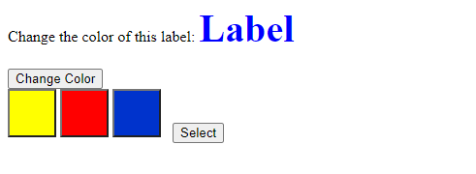

**Practical 13**

# Textbox configuration

***WebForm1.aspx:***

<%@ Page Language="C#" AutoEventWireup="true" CodeBehind="WebForm1.aspx.cs" Inherits="TextBoxConfig.WebForm1" %>

<!DOCTYPE html>

<html xmlns="http://www.w3.org/1999/xhtml">

<head runat="server">

<title></title>

</head>

<body>

<form id="form1" runat="server">

<div>

You can enable and disable this textbox:

<asp:TextBox ID="txtEnableDisable" runat="server"></asp:TextBox>

<br />

<asp:Button ID="btnEnableDisable" runat="server" OnClick="btnEnableDisable_Click" Text="Enable/Disable" />

<br />

<asp:TextBox ID="TextBox1" runat="server" Width="117px"></asp:TextBox>

<asp:Button ID="btnChangeWidth" runat="server" OnClick="btnChangeWidth_Click" Text="Change Width" />

</div>

</form>

</body>

</html>

***WebForm1.aspx.cs:***

using System;

using System.Collections.Generic;

using System.Linq;

using System.Web;

using System.Web.UI;

using System.Web.UI.WebControls;

namespace Practical13

{

public partial class WebForm1 : System.Web.UI.Page

{

protected void Page_Load(object sender, EventArgs e)

{

}

protected void btnEnableDisable_Click(object sender, EventArgs e)

{

if (txtEnableDisable.Enabled ==true)

{

txtEnableDisable.Enabled = false;

}

else

{

txtEnableDisable.Enabled = true;

}

}

protected void btnChangeWidth_Click(object sender, EventArgs e)

{

txtEnableDisable.Width =int.Parse(TextBox1.Text);

}

}

}

***WebForm1.aspx.designer.cs:***

namespace Practical13

{

public partial class WebForm1

{

protected global::System.Web.UI.HtmlControls.HtmlForm form1;

protected global::System.Web.UI.WebControls.TextBox txtEnableDisable;

protected global::System.Web.UI.WebControls.Button btnEnableDisable;

protected global::System.Web.UI.WebControls.TextBox TextBox1;

protected global::System.Web.UI.WebControls.Button btnChangeWidth;

}

}

***Output:***

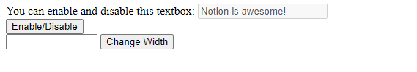



**Practical 14**

# Session State in SQL Server

***WebForm1.aspx:***

<%@ Page Language="C#" AutoEventWireup="true" CodeBehind="WebForm1.aspx.cs" Inherits="SessionState.WebForm1" %>

<!DOCTYPE html>

<html xmlns="http://www.w3.org/1999/xhtml">

<head runat="server">

<title></title>

</head>

<body>

<form id="form1" runat="server">

<div>

<table>

<tr>

<td colspan="2"><h1>Web Page 1</h1></td>

</tr>

<tr>

<td>Name:</td>

<td><asp:TextBox ID="txtName" runat="server"></asp:TextBox></td>

</tr>

<tr>

<td>Mobile:</td>

<td><asp:TextBox ID="txtMobile" runat="server"></asp:TextBox></td>

</tr>

<tr>

<td colspan="2"><asp:Button ID="btnSubmit" runat="server" Text="Submit" OnClick="btnSubmit_Click" /></td>

</tr>

</table>

</div>

</form>

</body>

</html>

***WebForm1.aspx.cs:***

using System;

using System.Collections.Generic;

using System.Linq;

using System.Web;

using System.Web.UI;

using System.Web.UI.WebControls;

namespace Practical14

{

public partial class WebForm1 : System.Web.UI.Page

{

protected void Page_Load(object sender, EventArgs e)

{

}

protected void btnSubmit_Click(object sender, EventArgs e)

{

Session["Name"] = txtName.Text;

Session["Mobile"] = txtMobile.Text;

Response.Redirect("WebForm2.aspx");

}

}

}

***WebForm1.aspx.designer.cs:***

//------------------------------------------------------------------------------

// <auto-generated>

// This code was generated by a tool.

//

// Changes to this file may cause incorrect behavior and will be lost if

// the code is regenerated.

// </auto-generated>

//------------------------------------------------------------------------------

namespace Practical14

{

public partial class WebForm1

{

/// <summary>

/// form1 control.

/// </summary>

/// <remarks>

/// Auto-generated field.

/// To modify move field declaration from designer file to code-behind file.

/// </remarks>

protected global::System.Web.UI.HtmlControls.HtmlForm form1;

/// <summary>

/// txtName control.

/// </summary>

/// <remarks>

/// Auto-generated field.

/// To modify move field declaration from designer file to code-behind file.

/// </remarks>

protected global::System.Web.UI.WebControls.TextBox txtName;

/// <summary>

/// txtMobile control.

/// </summary>

/// <remarks>

/// Auto-generated field.

/// To modify move field declaration from designer file to code-behind file.

/// </remarks>

protected global::System.Web.UI.WebControls.TextBox txtMobile;

/// <summary>

/// btnSubmit control.

/// </summary>

/// <remarks>

/// Auto-generated field.

/// To modify move field declaration from designer file to code-behind file.

/// </remarks>

protected global::System.Web.UI.WebControls.Button btnSubmit;

}

}

***Output:***

